Canice’s Family Typology


When I look at Todd’s typology I would see my family and most Irish families in the same category as Finland, but leaning more towards “The Egalitarian Nuclear Family”. In Ireland a family home is often a source of pride. And it is often the case that the family home has been in the family for generations. Ireland has one of the highest homeownership rates in the world (See figure 1) and it is often a matter of when you are going to buy a home not if. Latest statistics suggest that newer generations are opting to rent with the 81.4% dropping significantly since 2004. This I’m sure is due to lack of confidence in the property market after the devastation of the 2008 property crash. However, there are current fears of another property bubble in Ireland. (RTE.ie)

Figure 1: OECD 2004
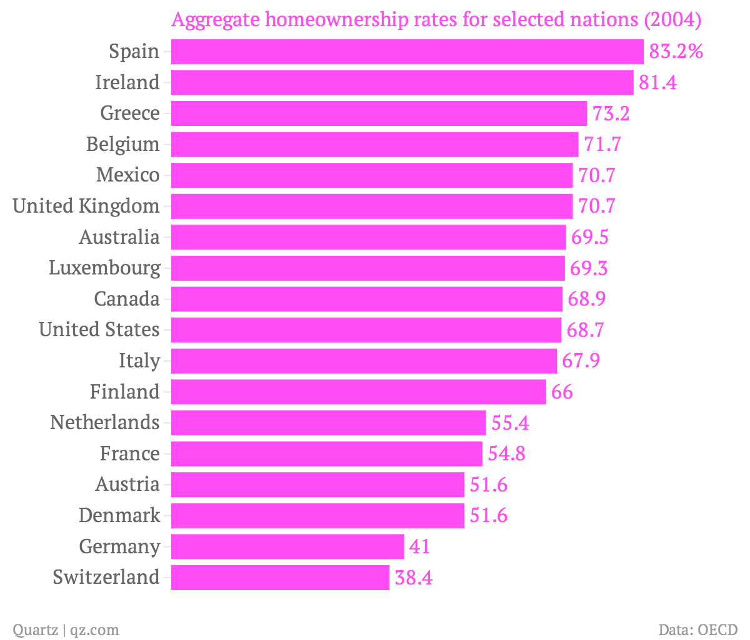

The opposite can be seen in Germany and Switzerland where people opt to rent instead of buy homes. This obsession with owning your own home leads to having pride in this home once it has been established as a family home. This pride is passed through the generations along with the property. This is especially evident in rural Ireland.

Becoming independent and achievement orientated is important in my own family. Of four boys in my family we have two master’s degrees, one Phd, along with my own current master’s studies. We were always encouraged by our parents to go to the next level and stand on our own two feet. 2 of my brothers have purchased their own homes and one is living abroad. My parents often refer to who will take the house when they are gone, which again shows this pride in the family home.

Do you think that we take our family practices (culture) to school, organisation and even to national level?


I agree completely with the above. We take a large part of our home culture with us to the external environment. Having good manners was always a priority for my mother. Before any of us left to go to a friends’ house the instruction was “Say please and thank you” and the first question on return was “did you say please and thank you?”. To this day this sticks with me and I use the words subconsciously. Also, if any of us received a card or present from an aunt or uncle, the first think we had to do was pick up the phone and make a phone call of thanks.

How family culture may affect workplace culture?

Seeing as the values I picked up in my family still influence me at a subconscious level today, I have no doubt that family culture affects workplace culture. I am lucky to have grown up with a very positive, respectful family culture. On the flip side of this there are people that would not been as lucky as to have grown up in this kind of culture and I’m sure their experiences would affect them in the same subconscious way as my “please and thank you”. Even the lack if these words in a workplace by a colleague could be the difference in creating a good working culture and a bad working culture. I believe that “thank you and please” are words that are really only noticed when they are missing from a conversation. This is just a small example of how one aspect my personal family culture has stayed with me and the impact one piece of culture might have for your entire life.

Have a nice Easter,

Canice
References:
Shaidul’s PhD
https://qz.com/167887/germany-has-one-of-the-worlds-lowest-homeownership-rates/
https://www.rte.ie/news/business/2018/0314/947350-cso-residential-property-prices/

